Topic: Measurement | EQ: What tools do we use to measure common items?
Questions  Length  Mass/ weight  Capacity  Time  Temperature  Angles  Speed | Notes:  To measure length, we often use rulers, measuring tape and trundle wheels  To measure weight/mass we often use scales, or cups/spoons (in cooking)  To measure capacity, we can use scales, measuring jugs or cups/spoons (in cooking)  To measure time, we can use a stop watch or clock  To measure temperature, we can use a thermometer  To measure angles we can use a protractor.  To measure speed, we can use a speedometer (found in a car), or a radar gun (used by police)

Activity
- What would you use to measure the following?
- Length of a pencil
- Flour to go into a recipe
- Water in a water bottle
- Weight of a person
- Length of a footy oval
- Temperature of a pool
- Length of a movie

- Show on the following measuring jug where you would need to fill up to get to following amount of water
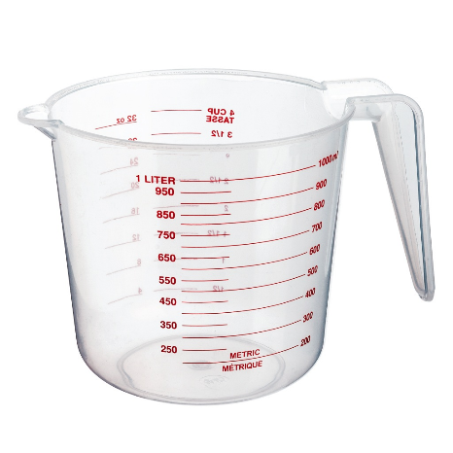  300mL |   750mL

- What are the following measurements?
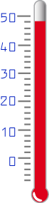 | 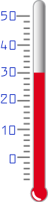
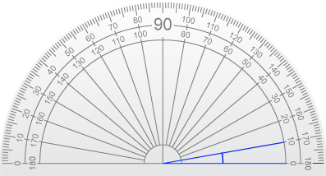 | 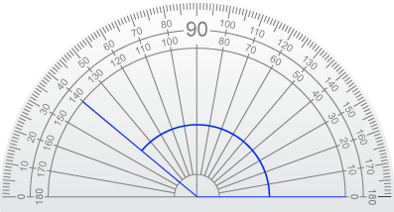
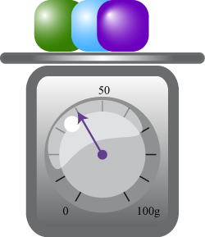 | 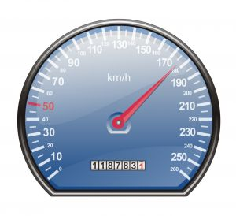
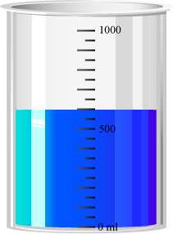 | 